Title of the Paper (14 point, Bold, Times New Roman)
Author Name Surname^{1*}, Author Name Surname² , Author Name Surname³
¹ firstauthor@eamil.com, ² secondauthor@eamil.com, ³ thirdauthor@eamil.com
¹ Department, Faculty, University, City, Country
*Corresponding author email:

General instructions for preparing the manuscript

The research paper should be written using MSWord, times new roman font, font size 12 normal (headings 14, bold), spacing between lines 1.5 on A4 size paper, and the page margins are 4 cm from the top margins. and 2.5 cm from the bottom, the right and the left, margin, and no more than 10 pages maximum in length, including figures, references and tables

ABSTRACT
The manuscript should contain an abstract within 300 words. The manuscript should have a self-contained, citation-free abstract and state briefly the purpose of the research, the principal results and major conclusions. Abstract should be in a single paragraph with running sentences. Do not use any subheading or point list within the abstract. Also, non-standard or uncommon abbreviations should be avoided, but if essential they must be defined at their first mention in the abstract itself.

Keywords:Authors are advised to writes 3-5 keywords related to the article. These keywords will be used for indexing p

Introduction

Mostly Papers starts with introduction. It contains the brief idea of work, requirement for this research work, problem statement, and Authors contribution towards their research. Recent references [1] should be included for showing previous work done and importance of current work. This section should be succinct, with no subheadings unless unavoidable [2, 3]. State the objectives of the work and provide an adequate background related to your work, avoiding a detailed literature survey or a summary of the results.
- Materials and Methods

This part should contain sufficient detail to reproduce reported data. It can be divided into subsections if several methods are described. Methods already published should be indicated by a reference [4], only relevant modifications should be described.
- Theory and Calculation

A Theory section should extend, not repeat, the background to the article already dealt with in the Introduction and lay the foundation for further work. In contrast, a Calculation section represents a practical development from a theoretical basis.

3.1 Mathematical Expressions and Symbols

Mathematical expressions and symbols should be inserted using equation tool of Microsoft word. References may be added for used equations to support its authenticity, e.g. this result has been analysed using Fourier series [5].

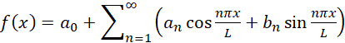 (1)
- Results and Discussion

This section may each be divided by subheadings or may be combined. A combined Results and Discussion section is often appropriate. This should explore the significance of the results of the work, don’t repeat them. Avoid extensive citations and discussion of published literature.

4.1 Figures and Tables

Authors are supposed to embed all figures and tables at appropriate place within manuscript. Figures and tables should neither be submitted in separate files nor add at the end of manuscript. Figures and Tables should be numbered properly with descriptive title. Each Figure/Table must be explained within the text by referring to corresponding figure/table number. Any unexplained or unnumbered Figure/Table will be dropped from the publication.

Table should be prepare using table tool within the Microsoft word and cited consecutively in the text. Every table must have a descriptive title and if numerical measurements are given, the units should be included in the column heading. Formatting requirement has been summarized in the Table 1.
Table 1:Summary of formatting requirement for the conference papers
Layout | Size | Margin
Single column | Letter (8.5” X 11”) | Top=1.25”  Bottom=1.25”  Left=1.5”  Right=1.5”
Font | Article Title | Headings | Subheadings | Reference list | Text
 | Times New Roman, 16 pt, Bold, Centered | Times New Roman, 11 pt, Bold, Left aligned | Times New Roman, 10 pt, Bold, Left aligned | Times New Roman, 8 pt, Justified | Garamond, 11 pt, Justified
Line Spacing | 1.25 | 1.25 | 1.25 | 1.25 | 1.25
Page number | We will format and assign page numbers

All figures should be cited in the paper in a consecutive order, author may be asked to provide separate files of the figure. Figures should be used in bitmap formats (Photoshop, TIFF, GIF, JPEG, etc.) with 300 dpi resolution at least unless the resolution is intentionally set to a lower level for scientific reasons. If a bitmap image has labels, the image and labels should be embedded in separate layer. Figure 1 shows old cover page of journal of modern materials published by AIJR.
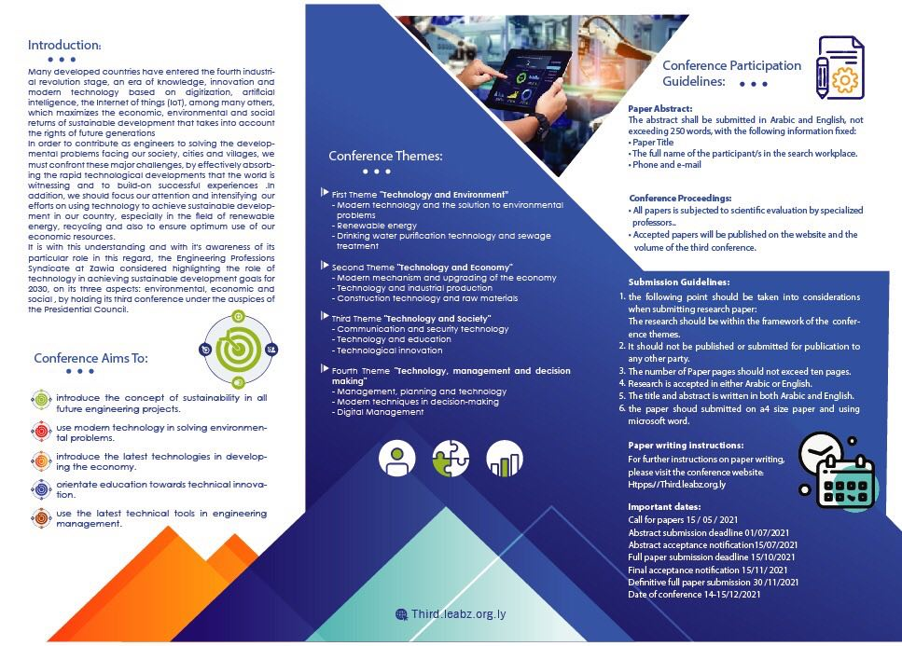

Figure 1. Conference information poster

- Conclusions
Each manuscript should contain a conclusion section, which may contain the main outcome of the work, highlighting its importance and relevance. Conclusion should be written in continuous manner with running sentences which normally includes main outcome of the research work, its application, limitation and recommendation. Do not use any subheading or point list within the conclusion.

- Acknowledgment
All acknowledgments (if any) should be included in a separate section before the references and may include list of peoples who contributed to the work in the manuscript but not listed in the author list, supporting grants, presentations, and so forth. The name of funding agencies should be written in full.

References

[1] W. S. Author, “Title of paper,” Name of Journal in italic, vol. x, no. x, pp. xxx-xxx, Abbrev. Month, year. https://doi.org/10.21467/ajgr

[2] W. S. Author, “Title of paper,” Name of Journal in italic, vol. x, no. x, pp. xxx-xxx, Abbrev. Month, year. doi: 10.21467/ajgr

[3] W. S. Author, “Title of paper,” Name of Journal in italic, vol. x, no. x, pp. xxx-xxx, Abbrev. Month, year. Access online on 24 March 2018 at https://journals.aijr.in/index.php/ajgr

[4] W. S. Author, “Title of paper,” Name of Journal in italic, vol. x, no. x, pp. xxx-xxx, Abbrev. Month, year. Access online on 20 March 2018 at https://www.aijr.in/journal-list/advanced-journal-graduate-research/

[5] W. S. Author, “Title of paper,” Name of Journal in italic, vol. x, no. x, pp. xxx-xxx, Abbrev. Month, year. Access online on 5 March 2018 at https://www.aijr.in/about/publication-ethics/

